THE IMPACT OF THE RECYCLING INDUSTRY ON POVERTY LEVELS IN SOUTH AFRICA’S INFORMAL ECONOMY: A CASE STUDY OF WASTE PICKERS IN PRETORIA

Blaauw, PF, Pretorius, AM, Schenck, CJ & Viviers, W
ABSTRACT
South Africa is gripped by high and rising levels of unemployment and poverty, which have conspired to create a society that is one of the most unequal in the world today. This is not helped by the fact that the troubled global and local economies are squeezing formal sector jobs in the country. As a result, many semi-skilled and unskilled workers have no choice but to enter the informal economy and perform survivalist-type work. Collecting and selling recyclable material is an interesting and increasingly important informal activity, yet it is largely overlooked at the policy level. As a result, waste pickers remain marginalised and their earnings and future prospects are highly uncertain. This paper analyses the impact of informal recycling on the poverty levels of street waste pickers in South Africa, using Pretoria (the capital) as a case study. A mixed-method approach informed the results. Structured interviews were conducted between July and September 2010, with 142 street waste pickers taking part in the survey. Among the findings were that low education and skills levels help to ensure that street waste pickers have little chance of joining the formal sector. Furthermore, the majority of street waste pickers have an average of four dependants, which places a heavy financial burden on them. Under such circumstances, the income from waste picking is insufficient to lift these people out of poverty. Yet some waste pickers display a surprising degree of entrepreneurial resilience and even pride at being able to independently make an honest living. A new policy position needs to be adopted which will help street waste pickers escape the socio-economic twilight zone in which they are currently trapped and be recognised for their important contribution to cities’ waste management systems.

KEYWORDS
Urban informal economy, recycling, street waste pickers, poverty, waste management system

Introduction and aim of the study
Despite progress having made on the economic development front since the first democratic elections in 1994, South Africa still faces the ‘trilemma’ of widespread inequality, poverty and unemployment (May, 2016). Inequality levels remained virtually unchanged between 2006 and 2011, with a Gini coefficient of between 0.65 and 0.69 (depending on the method of calculation used)—levels that are among the highest in the world (Statistics South Africa, 2014). Officially, though, the poverty position showed an improvement between 2006 and 2011. See Table 1.
Table 1: Poverty headcounts in 2006, 2009 and 2011
Poverty headcounts | 2006 | 2009 | 2011
Percentage of the population that is poor | 57.2% | 56.8% | 45.5%
Number of poor persons (millions) | 27.1 | 27.8 | 23.0
Percentage of the population living in extreme poverty | 26.6% | 32.4% | 20.2%
Number of extremely poor persons (millions) | 12.6 | 15.8 | 10.2
Source: Statistics South Africa (2014)
The latest announcements, however, from Statistics South Africa suggest that since 2010 this trend has been reversed, with the number of South Africans living in poverty on the increase. Statistician-General Pali Lehohla remarked in February 2015 that: “In 2010, 20% of South Africa’s population fell below the poverty line...This had increased to 21.5% by 2014” (City Press, 2015). Increased poverty levels go hand in hand with high and rising levels of unemployment, which have become another constant feature of the socio-economic and political climate in South Africa. High and rising unemployment implies that fewer low-skilled and unskilled jobs are available in the formal labour market (Van Heerden, 2015).
As a consequence of this, many desperate, low-skilled and unskilled people in South Africa are forced into the informal economy in an attempt to survive materially. Once in the informal economy they make a living by engaging in various lower tier informal economic activities. Car guarding, day labouring, small-scale retailing as well as waste picking on the streets are everyday sights across South Africa’s cities. Pretoria is no exception, having attracted large numbers of street waste pickers who are regularly seen pushing their trolleys across the urban sprawl (Schenck & Blaauw, 2011).

The literature generally defines waste pickers as small-scale, self-employed people who are mostly active in the urban informal economy (Hayami, Dikshit & Mishra, 2006:42; Schenck & Blaauw, 2011b). Various expressions are used to describe the activities of the waste pickers. Terms such as reclaimers, waste pickers, garbage pickers, recyclers, scavengers and waste salvagers are often encountered (Schenck & Blaauw, 2011b; Chvatal 2010; Samson 2010b). In Cape Town, for example, waste pickers have referred to their work as “skarreling”, “grab grab”, “mining” and “minza” (meaning “trying to survive”) or “ukuzizamela” (trying for yourself) (Benson & Vanqa-Mgijima, 2010; Van Heerden, 2015). The obvious entrepreneurial zeal that prompted these comments is a poignant reminder that even in the face of much adversity, some people are still imbued with a desire to make an honest living (Van Heerden, 2015).
The different terminology that is encountered is not simply a matter of academic interest (Samson, 2010a). It also helps to shape attitudes towards and perceptions about the people involved in this activity (Samson, 2010a; Schenck & Blaauw, 2011a). In this paper, we use the term ‘waste picker’ as it describes exactly the nature of these people’s activities.
Irrespective of the terminology used, the de facto situation is that informal recycling of various forms of plastic, glass, paper and metals is one of the ways in which many of the unemployed carve out a living in difficult socio-economic circumstances. Langenhoven and Dyssel (2007) indicated, with reference to the South African Yearbook for 2004/2005, that during this period roughly 37,000 people in South Africa earned a living from informal recycling.
Street waste pickers form the beginning of a long value chain in the recycling industry. See Figure 1.
Highest value  Lowest value | Manufacturing industries
Highest value  Lowest value | Brokers, wholesalers, other processors
Highest value  Lowest value | Buy-back centres, craftsmen, middlemen
Highest value  Lowest value | Informal waste collectors with own transport (hawkers)
Highest value  Lowest value | Individual, informal waste pickers
Figure 1: Hierarchy of role players in the recycling industry
Source: Wilson, Velis and Cheeseman (2006:800)
The recycling value chain links the production of post-consumer waste to its collection, sorting and transportation, and processing. Only then does it become an input in a new production process. Value is created at each stage. In general, though, the further away the actors in the value chain are from the production of post-consumer waste, the greater is their ability to extract value from it. The street waste pickers find themselves in a perilous position. Their income is based directly on their work rate. Yet exogenous factors such as the local availability of recyclable materials, global fluctuations in the commodity prices of the materials they collect and even the weather are all forces that impact their livelihoods but over which they have no control. Also, with no means to transport recyclable material to end users, they have no option but to deal with buy-back centres (middlemen) further along the value chain. Waste pickers’ dependence on middlemen and the uncertainty surrounding collections and prices means that earnings are always uncertain.
Uncertainty in earnings is a key element in understanding the poverty position of street waste pickers. Although they face the most uncertainty, their position in the recycling value chain is indispensable for all the other actors. In 2013, 8.7% of all recyclable paper in South Africa was exported (Plastics SA, 2015:8). This is not dissimilar to the 10% of recycled plastic that was exported in 2014. Also in 2013, 8.24% of all recovered paper in South Africa was exported (calculated from PRASA, 2014). We argue that studying how informal recycling impacts the poverty levels of street waste pickers in South Africa is fundamental to gaining an understanding of the value chain underpinning the recycling industry. This informs the goal of the paper which is to determine the impact of informal recycling on the poverty levels of street waste pickers in South Africa, using Pretoria (the capital city) as a case study. The aim can be broken down in two interdependent elements: the first being to establish a socio-economic profile of street waste pickers in Pretoria, and the second being to determine the impact of their informal activities on their poverty position. This paper utilises the findings of the first empirical micro study of street waste pickers in Pretoria.
Literature review: Contextualisation of the study
South Africa has a long history of people collecting waste off the streets in order to survive (Benson & Vanqa-Mgijima, 2010:2). The availability of poor people to take part in the reclaiming chain as well as the scale of private reclaiming have increased since the adoption of neo-liberal policies in South Africa (Benson & Vanqa-Mgijima, 2010; Van Heerden, 2015). Medina (2007) and Theron (2010) confirm that collecting and selling recyclable waste is an activity that protects many people from starvation. The existence of waste pickers should be considered further in the context of existing formal waste management systems (Schenck & Blaauw, 2011a; 2011b).
The international literature suggests that the official waste management systems in place in many cities, such as Cairo, could not be managed without the countless number of waste pickers and scrap collectors. These people often form the centre of waste collection services at no cost to central governments, local authorities or residents (Gerdes & Gunsilius, 2010). Dias (2009) states, for example, that in 2008, 5,100 tons of waste was collected by informal waste pickers in the streets and dumpsites in Belo Horizonte, Brazil. This amounted to 52% of all recyclable material accumulated. Clearly, street waste pickers make a significant contribution to national economies as they “...are entrepreneurs who add value merely by collecting and then transforming waste into tradable commodities” (Gerdes & Gunsilius, 2010:5; see also Hayami et al. 2006:42). South Africa’s municipal waste management systems, however, are seemingly struggling to accommodate the waste pickers on the streets and landfill sites of the country (Schenck & Blaauw, 2011b).
The evident inability of the South African local authorities to effectively acknowledge and engage with waste pickers regarding, for example, future changes to the recycling system has been called into question by authors such as Van Heerden (2015), and correctly so. Their stance flies in the face of the current trend towards participatory governance, which is supposed to inform public sector planning and policymaking in South Africa (Van Heerden, 2015). More specifically, it neglects the principle of “...participatory democracy, accountability, transparency, and public involvement...” which is enshrined in both the Constitution of the Republic of South Africa and in national and local waste management policies, including the National Waste Management Strategy (NWMS) (Van Heerden, 2015).
The literature reveals that it is not only local political factors that influence waste pickers’ livelihoods. Socio-economic forces at a global and local level are helping to shape the nature of informal waste management and the livelihoods of those engaged in it, however tenuously (Van Heerden, 2015). Marello and Helwege (2014) showed that in Latin America the number of waste pickers surged as more and more pressure was exerted on formal labour markets. This was accompanied by a decrease in individual waste picker earnings (Van Heerden, 2015). Benson and Vanqa-Mgijima (2010) described how the 2008 global economic recession had similar consequences for waste pickers in Cape Town (Van Heerden, 2015).
Apart from exogenous global and local factors that directly impact the lives of street waste pickers, several endogenous barriers prevent waste pickers from improving their socio-economic circumstances (Viljoen, Blaauw & Schenck, 2015). Low levels of schooling, inadequate language proficiency, unreliable and low levels of income, and limited access to basic social services are all barriers preventing waste pickers from moving upwards in the hierarchy of the informal economy (Viljoen et al., 2015). Waste pickers operate under a unique set of socio-economic circumstances. Therefore, designing policy interventions to address the inadequate response to their plight is challenging, requiring an in-depth knowledge of the prevailing conditions confronting waste pickers on South Africa’s streets and landfill sites.
A review of the literature from a South African perspective reveals that researchers are starting to pay attention to the lower tier of the informal economy, and waste pickers in particular. Waste pickers working and living on South Africa’s landfill sites have received the bulk of attention in the literature, with street waste pickers receiving less coverage (Chvatal, 2010; Samson, 2010a; Schenck & Blaauw, 2011b). Schenck and Blaauw (2011a; 2011b) conducted an exploratory study on street waste pickers in Pretoria (among other studies). More detailed, micro-level studies include those of Benson and Vanqa-Mgijima (2010) in Cape Town, McLean (2000) in Durban, Langenhoven and Dyssel (2007) in Mitchells Plain (Cape Town), Viljoen (2014) in selected cities in South Africa, and Van Heerden (2015) also in Cape Town. The study by Viljoen, Schenck and Blaauw (2012) is the only study to date that, to our knowledge, specifically highlights the important and often misunderstood role of buy-back centres in the recycling value chain.
The above-mentioned studies explore the socio-economic circumstances of the waste pickers at a micro level and arrive at mostly qualitative conclusions regarding poverty among the street waste pickers. We argue that a quantitative approach is needed to provide an accurate analysis of the impact of waste picking on the poverty levels of this vulnerable and often marginalised group in the informal economy. This has informed the research methodology discussed below.
The research methodology
Schenck and Blaauw (2011a) recognised several areas requiring further investigation during their qualitative study on waste pickers conducted in 2009. This study followed a mixed method approach, consisting of a quantitative survey coupled with qualitative questions. The questionnaire was developed around the themes and patterns emerging out of the results of the qualitative study of Schenck and Blaauw (2011a) in 2009. Appropriate qualitative questions were built into the questionnaire to illuminate some of the quantitative items. The post-positivist and constructivist thinking built into this approach allowed the participants to apply their own meaning to some of the questions (Creswell & Plano Clark, 2011:40).
The questionnaire was tested and revised. A significant benefit of the study was that a single experienced fieldworker was used to conduct the interviews. She is fluent in a number of the official South African languages and was able to translate the questionnaire to improve the respondents’ understanding of the questions. This was an important step as low literacy levels would otherwise have prevented many respondents (in the absence of assistance) from completing the questionnaires (Creswell & Plano Clark, 2011:14).
Initial observations before the survey was conducted suggested that there were between 150 and 200 street waste pickers active within the Pretoria city limits. The best places to find these people were at the buy-back centres where they sold the goods they had collected (Schenck & Blaauw, 2011a). The buy-back centres identified in Pretoria at the time belonged to only two companies which, for reasons of confidentiality and ethics, were designated as companies M and N (Schenck & Blaauw, 2011b). The fieldworker reported that she frequently encountered the same waste pickers at different buy-back centres. They would, for instance, deliver goods to one buy-back centre in a particular area on one day. The next day they would make their way to another buy-back centre, probably in search of better prices. Hayami et al. (2006) revealed similar movements between buy-back centres in their study of street waste pickers in India.
The resultant fluid nature of the research population necessitated the use of availability sampling to complete the survey. Consequently, the fieldworker was instructed to interview all the street waste pickers she could find who were willing to participate in the survey. From July to September 2010 she identified and interviewed waste pickers until no new interviewees could be found and information was saturated. In total, 142 respondents participated in the survey. It is naturally possible that not all the waste pickers in Pretoria were included in the study. However, we are satisfied that the research population was covered as comprehensively as possible, with only a couple of individuals refusing to be interviewed.
The descriptive and empirical results of the study appear below.
Results of the study
Demographic profile of the street waste pickers in Pretoria
Less than 3% of the street waste pickers in Pretoria were female. These women were either in a relationship with men or were office workers who took waste paper to the buy-back centres to earn additional income. More women are typically found on the landfill sites (Schenck, Swart, Blaauw & Viljoen, 2016). The reasons for this could be that women find the street trolleys too heavy to move and they are more vulnerable to the elements and crime on the streets than on the landfill sites (Chvatal 2010; Samson 2010a; Schenck & Blaauw, 2011b).
Table 2: Demographic profile of street waste pickers in Pretoria, South Africa (2010)
Country of origin  Province of origin | South Africa  Gauteng  Limpopo  Mpumalanga  KwaZulu-Natal | 100%  3%  63%  20%  9%
Gender | Male  Female | 97.2%  2.8%
Race | African | 100%
Language | Sepedi  IsiNdebele  Xitsonga  IsiZulu | 43%  20%  14%  11%
Age | 20 to 30  31 to 40  41 to 50  51 to 60 | 6%  22%  49%  23%
Education | Some primary schooling  Completed primary schooling  Some secondary schooling  Completed secondary schooling | 63%  13%  23%  1%
Marital status | Never married/single  Married  Separated/divorced  Widowed | 33%  47%  18%  2%
Dependants | Average  No dependants  9 dependants | 4%  14%  1%
Living conditions | Living with their family  Backyard rooms  In the veld or under bushes  On the street  Backyard shacks  Men’s hostels in the townships | 4%  4%  15%  69%  4%  4%
Source: Survey data
Although all the respondents were born in South Africa, the majority were migrants from the rural areas in other provinces, as seen from Table 2. The Eastern Cape, Free State and North West provided only 4% of the respondents. None of the waste pickers were born in the Western Cape or the Northern Cape. This information correlates well with the languages spoken by the respondents. Sepedi and isiNdebele are the languages of those who traditionally live close to Pretoria. The small number of Setswana-speaking people (2%) was surprising, though, as this language is spoken by another group of people who traditionally live close to Pretoria (Schenck & Blaauw, 2011).
The street waste pickers’ ages differed in distribution from those of day labourers (that is, men who stand on the side of the road looking for employment on a casual basis for the day) who were generally between 20 and 30 years of age (Blaauw, 2010). It seems as if waste picking is more physically manageable for older people than day labour work which involves standing next to the road for many hours and then engaging in hard physical labour (Schenck & Blaauw, 2011b).
Although many of the waste pickers indicated that they had previously had full-time jobs, these had mainly been temporary, short-term menial jobs. The workers’ generally low levels of schooling would make it very difficult for them to take up sustainable employment in the formal economy. See Table 2 and Figure 2 for some insight into educational achievements among the Pretoria waste pickers.
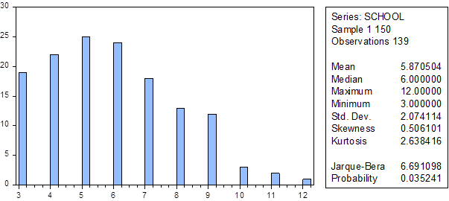
Figure 2: Highest grade completed by the Pretoria street waste pickers (2010)
Source: Survey data
Most of the respondents cited “poverty” or “lack of money” as the main reason for their having left school before completing Grade 12. “Had to look after the cattle” and “being a herd boy” were also given as reasons by waste pickers who hailed from rural areas (Schenck & Blaauw, 2011b). Some said that they could not afford school uniforms, while others were living on farms and could not travel the necessary distance to the nearest school, or the school they attended in primary school did not offer secondary school education (Schenck & Blaauw, 2011b). The problem of limited schooling also emerged from the qualitative study by Schenck and Blaauw (2011a), while Samson (2010b) states that in her study, most waste pickers had only some primary school education.
Less than half the respondents were married. The fieldworker observed a distinctive disconnectedness between the waste pickers and their families. This unhappy state of affairs was also confirmed when the respondents were asked to indicate how often they visited their families. A staggering 84% of the respondents saw their families only twice a year or less. Only 3% saw their families daily, 1% weekly, 6% monthly and another 6% quarterly. Like others engaging in informal activities such as day labourers, the waste pickers also maintained that they only visited their families if they had the financial resources to do so (Blaauw, 2010).
These observations are very important when considered against the backdrop of street waste pickers’ migratory status from rural areas, which is where their families live. This is highlighted in Figure 3 below.

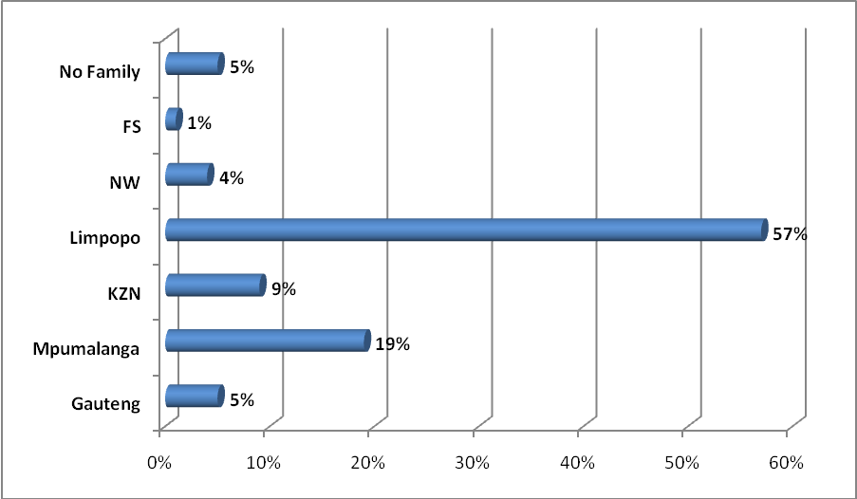
Figure 3: Provinces where the families of the Pretoria street waste pickers reside (2010)
Source: Survey data; Schenck & Blaauw (2011b)
Given the distances involved, it is understandable that if waste pickers do not earn enough, they are unable to visit their families regularly. As a result, family ties could be weakened or severed altogether (Schenck & Blaauw, 2011b). This has important implications for their level of multi-dimensional poverty. Family ties and relationships are an important component of being poor on a subjective level. The subjective components of being poor are no less severe than the objective or monetary dimension of poverty.
Another element contributing to the subjective component of their poverty-stricken experience is the effect of living on the streets. They have little access to amenities such as water, toilets and washing facilities. Respondents highlighted this as one of the greatest difficulties that they faced. The waste pickers living on the street or in the open veld (96%) went to filling stations and shops for water and toilet facilities. Some also used streams to wash themselves and their clothes. Certain buy-back centres made some facilities available for the waste pickers (Schenck & Blaauw, 2011b).
The respondents either prepared food for themselves where they slept on the street or in the veld. Alternatively, they bought food at the shops. A third (36%) indicated that they also regularly received food from churches. Another source of food was the dustbins put out by residential homes and restaurants (Schenck & Blaauw, 2011b).

Waste pickers’ daily lives and collection activities
The majority of the Pretoria waste pickers participating in the study had evidently entered waste picking not long before they were interviewed. Nine out of every ten waste pickers interviewed said that they became waste pickers during the preceding five years. One of the respondents had been engaged in the activity for 12 years (the longest period of all respondents), having started in 1998.
It was reported that the first priority upon entering the ‘business’ of collecting waste on the street was to obtain a trolley, as a matter of urgency. Ideally, the waste picker would find a friend willing to share a trolley. Alternatively, he/she might use boxes to carry items until he/she was in a position to buy, make or steal a trolley (McLean, 2000). Some respondents admitted to having stolen a trolley from a supermarket parking area. McLean (2000) also found that in Durban, waste pickers collecting goods with a trolley earned more because they were able to move faster and consequently collect more effectively. Figure 4 illustrates some of the modifications made to their trolleys by the street waste pickers.
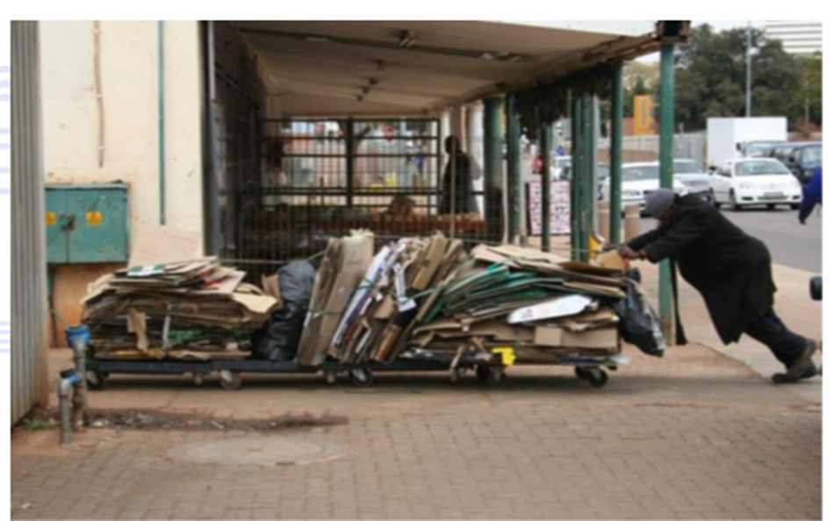
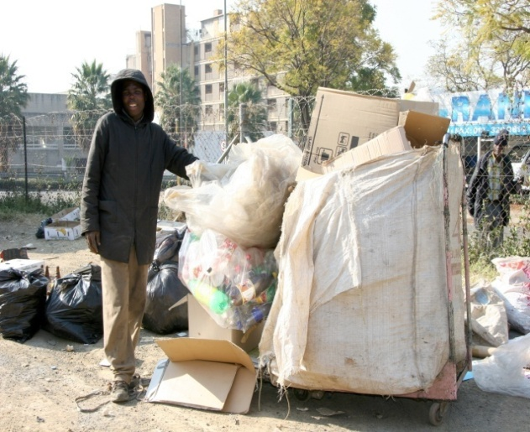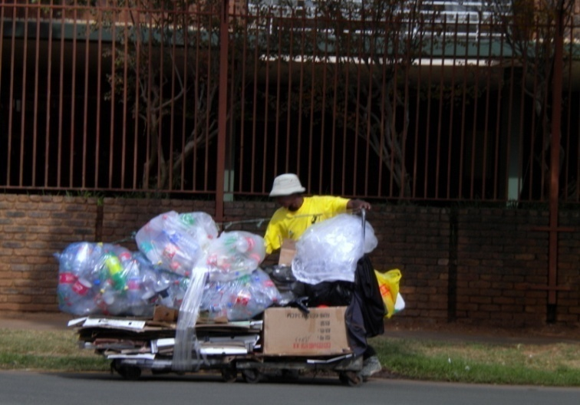
Figure 4: Some street waste pickers with their modified trolleys
Source: Fieldwork; Schenck & Blaauw (2011b)
The waste pickers all described a similar daily routine. Most indicated that they began collecting between 06.00 and 08.00 in the morning, and delivered their waste any time between 10.00 and 15.00. On municipal waste collection days in Pretoria’s suburbs, the waste pickers would search through dustbins and remove ‘valuable’ items before the municipal waste removal trucks arrived. Apart from recyclable waste, the waste pickers also collected ‘valuables’ for themselves. Food, electronic devices such as cell phones, pots and pans, blankets and detergent were reserved for personal use, to sell and to “give away as gifts” (McLean, 2000:18; Samson, 2010b; Schenck & Blaauw, 2011b).
It was obvious that the waste pickers faced working conditions that can only be described as harsh. They were exposed to the elements, the trolleys were heavy to push over long distances and they were in constant danger of being run over by passing cars. Surprisingly, most answered in the negative when asked whether they had ever experienced any work-related injuries. Moreover, the Pretoria street waste pickers did not cite crime as being a major concern (Schenck & Blaauw, 2011b). This perception differed significantly from the waste pickers of Mitchells Plain in Cape Town for whom theft was a significant stumbling block in their day-to-day activities (Langenhoven & Dyssel, 2007). McLean (2000) and Langenhoven and Dyssel (2007) cited the weather as being a potentially serious problem for waste collectors. Bad weather not only makes collection more difficult, but the buy-back centres also pay less if collected paper or cardboard boxes are damp (Schenck & Blaauw, 2011b).
Buy-back centres buy paper, cardboard boxes, plastic bottles and in some instances scrap metal (Viljoen et al., 2012). During the survey, it emerged that the recyclable waste was purchased by the two companies for fixed prices, but these prices differed significantly between the two companies. Company M, for example, offered lower prices for boxes and white paper than Company N. After delivering what they had collected, most respondents would rest, eat, drink and socialise. Some began working again later in the day to start accumulating waste for the following day’s delivery (Schenck & Blaauw, 2011b). This routine formed the basis of the everyday existence of the people interviewed, with no alternative scenario evidently open to them. How this contributed to or helped to alleviate their state of poverty goes to the core of the empirical investigation.
Waste pickers’ income and poverty analysis
It was clear that the street waste pickers did not receive a fixed income or monthly salary. Nor were any of the respondents receiving disability or old age grants at the time—which was to be expected given the physical demands of waste picking. A few (33.8% of the) respondents did, however, receive income in the form of a child support grant. In the midst of their highly variable and uncertain income, a small consolation for waste pickers is the fact that this uncertainty extends to all forms of informal employment, including car guarding and day labouring (Blaauw, 2010).
Given waste picking’s highly variable returns, three measures of income were constructed using the self-reported earnings of the street waste pickers surveyed:

• Income from recycling last week (the week before the interview)
• Income from waste picking in a good week
• Income from waste picking in a bad week

The average weekly income earned by street waste pickers during the week before the interview was ZAR 156.35 (USD 21.32; Euro 16.53). The three measures of weekly income were converted into monthly values by multiplying by four. For those individuals who indicated that they received a child grant, the number of eligible children was multiplied by the value of the monthly grant (ZAR 250 [USD 34.01; Euro 26.44] at the time of the interview) and this total amount was added to the waste pickers’ earnings to get a total monthly income which was used in the poverty analysis. This action provided a more nuanced view of the ability of the street waste pickers to support themselves and/or their families.
Table 3 summarises the average monthly income of the survey respondents according to the measures described above.

Table 3: 2010 average monthly income levels of street waste pickers in Pretoria according to various measures
 | ZAR | USD | Euro
Last week | 614.94 | 83.87 | 65.03
Good week | 1142.16 | 155.77 | 120.78
Bad week | 448.63 | 61.18 | 47.44
Last week + child grant | 746.23 | 101.77 | 78.91
Good week + child grant | 1273.45 | 173.67 | 134.66
Bad week + child grant | 579.93 | 79.09 | 61.33
Source: Survey data
In South Africa, no official poverty line is set at present. However, two measures/benchmarks of poverty are regularly used. We used these two measures in the Pretoria study to analyse the adequacy of waste picker earnings. These values were calculated by Statistics South Africa (StatsSA) and the South African Labour and Development Research Unit (SALDRU) (Statistics South Africa, 2015; Budlender, Leibbrandt & Woolard, 2015) and both measures indicate a lower bound and an upper bound margin—as indicated in Table 4. The lower bound amounts for 2010 are ZAR 484.66 and ZAR 516.58; and the upper bound amounts are ZAR 753.59 and ZAR 1008.01.
The average monthly income based on the income earned during the week preceding the interviews amounted to ZAR 614.94 (USD 83.87; Euro 65.03). This average is more than both the amounts provided as lower bounds, but does not reach the upper bounds. If these recyclers were only taking care of themselves, the average income earned in the week preceding the interview would be enough for them not to be classified as poor (based on the lower bounds). When we zoom in and consider the respondents as individuals, 52%, 53%, 70% or 92% of them would be classified as poor based on the four different poverty measures.
The average monthly income earned during a good week of waste picking (ZAR 1142.16) is higher than both of the upper bounds. Thus, three of the measures indicate a poverty rate of only 1%. Based on the high upper bound of SALDRU (see Table 4), only 36% of the respondents would be considered to be poor—if they only had to support themselves with their recycle income.
During a bad week of waste picking, the picture changes completely. The average income of ZAR 448.63 (USD 61.18; Euro 47.44) is lower than all of the poverty measures. It therefore comes as no surprise that during a bad week, between 91% and 98% of the recyclers in the sample would be classified as poor in terms of the income they earn. The analysis was further refined to also take cognisance of the dependants of the street waste pickers.
Table 4: Poverty rates of street waste pickers in Pretoria (2010)
 | Poverty threshold (weekly income)
 | Lower bound StatsSA  ZAR 484.66  (USD 66.10;  Euro 51.25) | Lower bound SALDRU  ZAR 516.58  (USD 70.45;  Euro 54.63) | Upper bound StatsSA  ZAR 753.59  (USD 102.77;  Euro 79.69) | Upper bound SALDRU  ZAR 1008.01  (USD 137.47;  Euro 106.59)
Percentage below poverty 2010
(supporting only him/herself from recycle income)
All (last week) | 52 | 53 | 70 | 92
All (good week) | 1 | 1 | 1 | 36
All (bad week) | 91 | 91 | 92 | 98
Percentage below poverty 2010
(recycler + dependants, recycle income + grant)
All (last week) | 88 | 88 | 94 | 96
All (good week) | 81 | 81 | 90 | 91
All (bad week) | 97 | 97 | 100 | 100
Source: Survey data
The above analysis suggests that waste picking does present an opportunity for individuals to support themselves and to lift themselves out of poverty. However, the picture changes considerably when the number of dependants is considered. The average number of dependants among the recyclers interviewed was 3.8; this means that the average recycler has to earn enough to support 4.8 people. The bottom part of Table 4 indicates the poverty rates, taking into account the number of dependants per individual recycler as well as the additional income received in the form of child grants.
Based on the lower bounds, 88% of the recyclers would be classified as poor when one considers the income earned during the week preceding the interviews. Only four of the recyclers with dependants earned enough not to be viewed as ‘poor’. During a good week, 81% would be considered poor based on the lower bounds. Again, the impact of dependants dominated—only 12 individuals who were taking care of dependants were not below the poverty line. As was evident from the low average income during a bad week, the poverty rates during a bad week were almost 100%. Therefore, not one of the recyclers taking care of dependants was above the poverty line during a bad week of waste picking.
McLean (2000) noted the same vulnerability of waste pickers in her Durban study. Waste pickers mostly lived under conditions of extreme poverty, having no visible assets except perhaps a trolley. They could not afford accommodation and could barely afford food, let alone support a family (Schenck & Blaauw, 2011b). The Pretoria waste pickers faced similar conditions.
Towards explaining the waste pickers’ income
In an attempt to identify determinants of waste picking income, two of the income variables—income earned in a good week (GOODWEEK) and income earned during the week preceding the interviews (LASTWEEK)—were regressed on a few explanatory variables. The results are reproduced in Table 5.
Table 5: Results of OLS regression analysis
 | DEPENDENT VARIABLE
 | GOODWEEK |  | LASTWEEK
 | Coefficient | Probability | Coefficient | Probability
CONSTANT | ***204.22 | 0.0020 | ***123.89 | 0.0009
AGE | 6.25 | 0.2213 | -0.58 | 0.8775
SCHOOL | ***13.50 | 0.0000 | ***9.21 | 0.0000
HOURS | -17.93 | 0.4029 | -6.50 | 0.4733
YEARS | *-5.95 | 0.0773 | ***-8.98 | 0.0003
PAPERPLASTIC | **55.81 | 0.0388 | ***49.20 | 0.0040
GLASSMIX | ***155.58 | 0.0000 | ***137.12 | 0.0000
METALMIX | *119.67 | 0.0822 | ***150.42 | 0.0000
Observations | 139 |  | 139
Adjusted R² | 0.1144 |  | 0.2531
Regressions were estimated with White heteroskedasticity-consistent standard errors and covariance:

* Statistically significant at 10%
** Statistically significant at 5%
*** Statistically significant at 1%

Apart from the variables included in Table 5, a few more explanatory variables were considered. The majority of recyclers made use of a trolley to transport their products; thus, there was not enough variation in the sample to test for the effect of trolleys. We did, however, test for whether the origin of the trolley and any modifications to it made a difference to the waste pickers’ income. Our thinking was that the tailor-made trolleys might work better. This variable had a positive coefficient in the good week analysis but it was not statistically significant. In the last week analysis, the sign turned negative but was also insignificant.
With only two females in the respondent group, gender was ignored; the same went for marital status. Whether the respondents held full-time employment before was not significant. There was also insufficient variation to justify the inclusion of the usual schooling categories (some primary school, primary complete, some secondary school, secondary complete, tertiary education). In the end, the highest grade passed at school was included in the analysis.
Focusing on the individual characteristics of the respondents, the estimation regarding age was inconsistent in terms of sign and also not statistically significant. The years of schooling variable was significant at 1% in both models. One additional year of schooling added between ZAR 9.20 (USD 1.25; Euro 0.97) and ZAR 13.50 (USD 1.84; Euro 1.43) to weekly earnings. We argue that increased levels of schooling, i.e. the ability to read and write, give waste pickers the ability to better evaluate the different prices from buyback-centres and to determine the best possible product mix in order to maximise their income. The starting time for the waste picking activity, represented by HOURS, was not significant. It might have been expected that the early starters would earn more. Yet while the expected negative sign was obtained, it was not statistically significant. The variable YEARS was an indication of the number of years that the individual had been active in waste picking. The negative coefficient in both models indicated that the newcomers earned more than the more experienced recyclers. The reasons for this might be a combination of younger waste pickers having more energy and being able to increase their productivity accordingly. This hypothesis must obviously be tested in future qualitative research, focusing on this aspect.
A comparison of the kind of products being recycled yielded the expected results. The base category in the analysis was the group that focused only on paper (including paper, boxes, etc.). Adding plastic to paper products added between ZAR 49.20 and ZAR 55.81 per week. The more lucrative products turned out to be a mix of paper, plastic and either glass (GLASSMIX) or metals (METALMIX). From the regression results it is evident that recyclers can increase their earnings by not focusing on paper collection only. A combination of paper and plastic delivers higher incomes. Adding glass and metals (iron and copper) to paper and plastic boosts income even more.
Conclusions and recommendations
Theoretically, waste picking has the potential to lift people out of poverty and allow them to take care of themselves—to be self-reliant. In reality, however, the majority of street waste pickers have an average of four dependants and under such circumstances the income derived from waste picking is not enough to enable them to break free from poverty’s powerful grip. Apart from the obvious hardship it creates, the poverty trap is particularly disturbing in the sense that it does little to strengthen family ties since most of the waste pickers’ families live in remote rural areas.
Forced into the informal economy by a combination of local and global forces, Pretoria’s street waste pickers demonstrated that, given their low education and skills levels, they had little chance of joining the formal sector. Most were between the ages of 40 and 49, and were engaging in labour-intensive and physically-exhausting work, with a number of exogenous factors influencing the income that they earned in the process.
The waste pickers surveyed did not earn enough to support a family, but nevertheless engaged in this work in order to survive and sustain themselves. Blaauw’s conclusion (2010:200) in his study on day labourers in South Africa: “there is no economic rationale for participation in this activity: it is merely a survival strategy for those involved in it” is backed up by the Pretoria findings. However, what alternatives await these people? Waste pickers are able to do something constructive instead of resorting to crime, for example. Given their limited experience and meagre contribution to human capital in a conventional sense, there is actually no viable legal alternative for them to pursue in order to be economically active.
Even though waste picking does not provide an income that is stable or allows the waste picker to escape poverty, it does instil a sense of self-reliance and can form part of the ‘agency’ component of Sen’s capability approach (Drèze & Sen, 1989; Sen, 1999). Sen’s explanation of agency suggests that the achievement of the economic agent can be evaluated in terms of his or her own values and goals. Even if waste picking seems to be an irrational choice given the low returns and hardship that accompany it, one must not underestimate the value it brings to a waste picker’s self-esteem and sense of empowerment (Sen, 1999). This self-reliance must be nurtured and ways found to reduce some of the barriers, which would then allow waste pickers to deliver (and extract) more value higher up the value chain.
A number of authors (e.g. Dias, 2009; Samson, 2010a, 2010b; Theron, 2010; Schenck & Blaauw, 2011a, 2011b; Viljoen, 2014; Viljoen et al., 2015) propose a range of policy options to realise this goal. Organising waste pickers to afford them a voice and greater representation, recognising them as part of cities’ waste management system and also acknowledging their contribution to the environment would produce benefits at many different levels. In order to find sustainable solutions to the problem of insufficient income, conversations should be initiated with the buy-back centres, municipalities and, even more importantly, the waste pickers themselves. All these role players are currently functioning in silos, effectively cut off from one another. Greater synergy between the three main role players could lay the foundation for waste pickers to move up the value chain and engage in activities that are more mentally and financially rewarding.
Any attempt to increase earnings is linked to the endogenous and exogenous aspects of the socio-economic and political context in which street waste pickers operate. Unless this complexity is acknowledged and acted upon by policymakers in a sincere attempt to uphold the Constitution, attempts by vulnerable people to make the best of a bad situation will be unsuccessful and they will remain trapped in an ongoing and undignified spiral of poverty and economic marginalisation.
Reference List
Benson, K., & Vanqa-Mgijima, N. (2010). Organising on the streets: a study of reclaimers in the streets of Cape Town. http://www.inclusivecities.org/toolbox/Organizing_on_the_Streets_web. pdf. Accessed 15 August 2016.
Blaauw, P.F. (2010). The socio-economic aspects of day labouring in South Africa. Unpublished DCom thesis, Department of Economics and Econometrics, University of Johannesburg, South Africa.
Budlender, J., Leibbrandt, M., & Woolard, I. (2015). South African poverty lines: a review and two new money-metric thresholds. Southern Africa Labour and Development Research Unit (SALDRU) Working Paper Number 151, Cape Town: SALDRU, University of Cape Town.
Chvatal, J. (2010). A study of waste management policy implications for landfill waste salvagers in the Western Cape. Unpublished MA dissertation, University of Cape Town.
City Press. (2015). More South Africans living in poverty – Stats SA. http://www.news24.com/Archives/City-Press/More-South-Africans-living-in-poverty-Stats-SA 20150429. Accessed 4 September 2016.
Creswell, J.W., & Plano Clark, V.L.P. (2011). Designing and conducting mixed methods research. 2nd edition. Thousand Oaks, CA: Sage.
Dias, S.M. (2009). Trajectories and memories—waste & citizenship forums: unique experiments of social justice and participatory governance. English abstract from unpublished PhD thesis, Federal University of Minas Gerais State, Belo Horizonte, Brazil.
Drèze, J., & Sen, A. (1989). Hunger and Public Action. Oxford: Oxford University Press.
Gerdes, P., & Gunsilius, E. (2010). The waste experts: enabling conditions for informal sector integration in solid waste management. http://www2.gtz.de/dokumente/bib-2010/gtz2010-0137en-informal-sector-solid-waste-management.pdf. Accessed 10 February 2011.
Hayami, Y., Dikshit, A.K., & Mishra, S.N. (2006). Waste pickers and collectors in Delhi: poverty and environment in an urban informal sector. Journal of Development Studies, 42(1), 41–69.
Langenhoven, B., & Dyssel, M. (2007). The recycling industry and subsistence waste collectors: a case study of Mitchells Plain. Urban Forum, 18(1), 114–132.
Marello, M., & Helwege, A. (2014). Solid waste management and social inclusion of waste pickers: opportunities and challenges. Boston: Global Economic Governance Initiative, Working Paper 7.
May, J. (2016). “Complex, wicked and impure”. Paper delivered at the World Nutrition 2016 Conference, University of the Western Cape, Cape Town, South Africa, 30 August to 3 September 2016.
McLean, M. (2000). Informal collection: a matter of survival amongst the urban vulnerable. Africanus, 30(2), 8–26.
Medina, M. (2007). The world’s scavengers: salvaging for sustainable consumption and production. Lanham: Altamira Press.
Paper Recycling Association of South Africa (PRASA). (2014). PRASA Newsletter May 2014. http://www.recyclepaper.co.za/wp-content/uploads/2015/08/LB410-2013-PRASA-statistics_1pager_Final.pdf Accessed 13 June 2016.
Plastics SA. (2015). Plastics recycling in South Africa 2014. http://www.plasticsinfo.co.za/wp-content/uploads/2015/06/Executive-Summary-May-2015.pdf Accessed 13 June 2016.
Samson, M. (2010a). Reclaiming livelihoods: the role of reclaimers in municipal waste management systems.
http://www.groundwork.org.za/Publications/Reclaiming%20Livelihoods.pdf. Accessed 18 June 2016.
Samson, M. (2010b). Reclaiming reusable and recyclable materials in Africa: a critical review of English language literature. http://www.inclusivecities.org/research/RR6_Samson.pdf. Accessed 18 June 2016.

Schenck, R., & Blaauw, D. (2011a). Living on what others throw away: an exploration of the socioeconomic circumstances of people collecting and selling recyclable waste. The Social Work Practitioner-Researcher, 23(2), 135–153.
Schenck, R., & Blaauw, P.F. (2011b). The work and lives of street waste pickers in Pretoria—a case study of recycling in South Africa’s urban informal economy. Urban Forum, 22(4): 411–430.
Schenck, R., Swart, R., Blaauw, D., & Viljoen, K. (2016). Food security, nutrition and socio-economic status of the waste pickers on selected landfill sites in South Africa. Paper delivered at the World Nutrition 2016 Conference, University of the Western Cape, Cape Town, South Africa, 30 August to 3 September 2016.
Sen, A. (1999). Development as Freedom. New York: Knopf.
South African Reserve Bank (SARB) (2016a). Selected historical rates: Rand per US Dollar. http://www.resbank.co.za/Research/Rates/Pages/SelectedHistoricalExchangeAndInterestRates.aspx. Accessed 3 September 2016.
South African Reserve Bank (SARB) (2016b). Selected historical rates: Rand per Euro. http://www.resbank.co.za/Research/Rates/Pages/SelectedHistoricalExchangeAndInterestRates.aspx. Accessed 3 September 2016.
Statistics South Africa (StatsSA). (2014). Poverty Trends in South Africa: An examination of absolute poverty between 2006 and 2011. Report No. 03-10-06, Statistics South Africa, Pretoria, South Africa.
Statistics South Africa (StatsSA). (2015). Methodological report on rebasing of national poverty lines and development of pilot provincial poverty lines. Technical Report 03-10-11, Statistics South Africa, Pretoria, South Africa.
Theron, J. (2010). Options for organising waste pickers in South Africa. http://www.wiego.org/publications/Organizing_Waste_Pickers_S_Africa.pdf. Accessed 10 August 2016.
Van Heerden, A. (2015). Valuing waste and wasting value: Rethinking Planning with Informality by Learning from Skarrelers in Cape Town’s Southern Suburbs. Unpublished Master’s Dissertation in City and Regional Planning, School of Architecture, Planning and Geomatics, University of Cape Town.
Viljoen, K., Schenck, C.J., & Blaauw, P.F. (2012). The role and linkages of buy-back centres in the recycling industry: Pretoria and Bloemfontein. Acta Commercii, 12, 1–12.
Viljoen, J.M.M. (2014). Economic and social aspects of street waste pickers in South Africa. Unpublished PhD thesis, Department of Economics and Econometrics, University of Johannesburg.
Viljoen, K., Blaauw, P., and Schenck, R. (2015). “I would rather have a decent job”: Barriers preventing street waste pickers from improving their socioeconomic conditions. Pretoria: Economic Research Southern Africa (ERSA) Working Paper 498, ERSA, Cape Town.
Wilson, D.C., Velis, C., & Cheeseman, C. 2006. Role of informal sector recycling in waste management in developing countries. Habitat International, 30(4):797–808.

School of Economics, North-West University (Potchefstroom Campus), South Africa
School of Economics, North-West University (Potchefstroom Campus), South Africa
Department of Social Work, University of the Western Cape, South Africa
TRADE research entity, North-West University (Potchefstroom Campus), South Africa
A mixed method approach is one that focuses “on collecting, analysing, and mixing both quantitative and qualitative data in a single study or series of studies. Its single premise is that the use of quantitative and qualitative approaches in combination provides a better understanding of research problems than either approach alone” (Creswell & Plano Clark, 2011:5).
During the qualitative study by Schenck and Blaauw (2011a), the fieldworkers investigated whether the waste pickers had children or dependants. From the feedback obtained in that exploratory study, it was not always clear whether the concepts of ‘children’ and ‘dependants’ were correctly interpreted by the respondents (Schenck & Blaauw, 2011b). The fieldworker in this study took the time to explain these concepts clearly, and was therefore able to obtain a more reliable estimate of the number of people, depending on the waste pickers interviewed.
No foreigners were interviewed in the Pretoria study at the time. This picture may obviously have changed since the study was done.
The USD and Euro values were calculated using the average of the daily exchange rates for the period of the fieldwork obtained from the South African Reserve Bank (SARB, 2016a; 2016b).
These were calculated by expressing the published poverty lines in 2010 prices. See Table 4 for USD and Euro levels.

